These APIs can be used to check status, fetch details from CKYC registry.

#### **Prerequisites**

Server :

* Infrastructure: Up and running cloud or on premise server instance
* Java 17 is required. [or docker for docker based deployment]
* 2CPU, 4GB RAM
* The Server could access CKYC’s endpoints in outbound traffic
* Valid keystore with Public Key and Private Key in .jks format.
* The server could access Digio’s endpoints in outbound traffic.

IP Whitelisting :

* IP Addresses to configure in CKYC Portal will be the IP Address of your server’s outgoing IP.  
  Screen where this configuration is to be done:

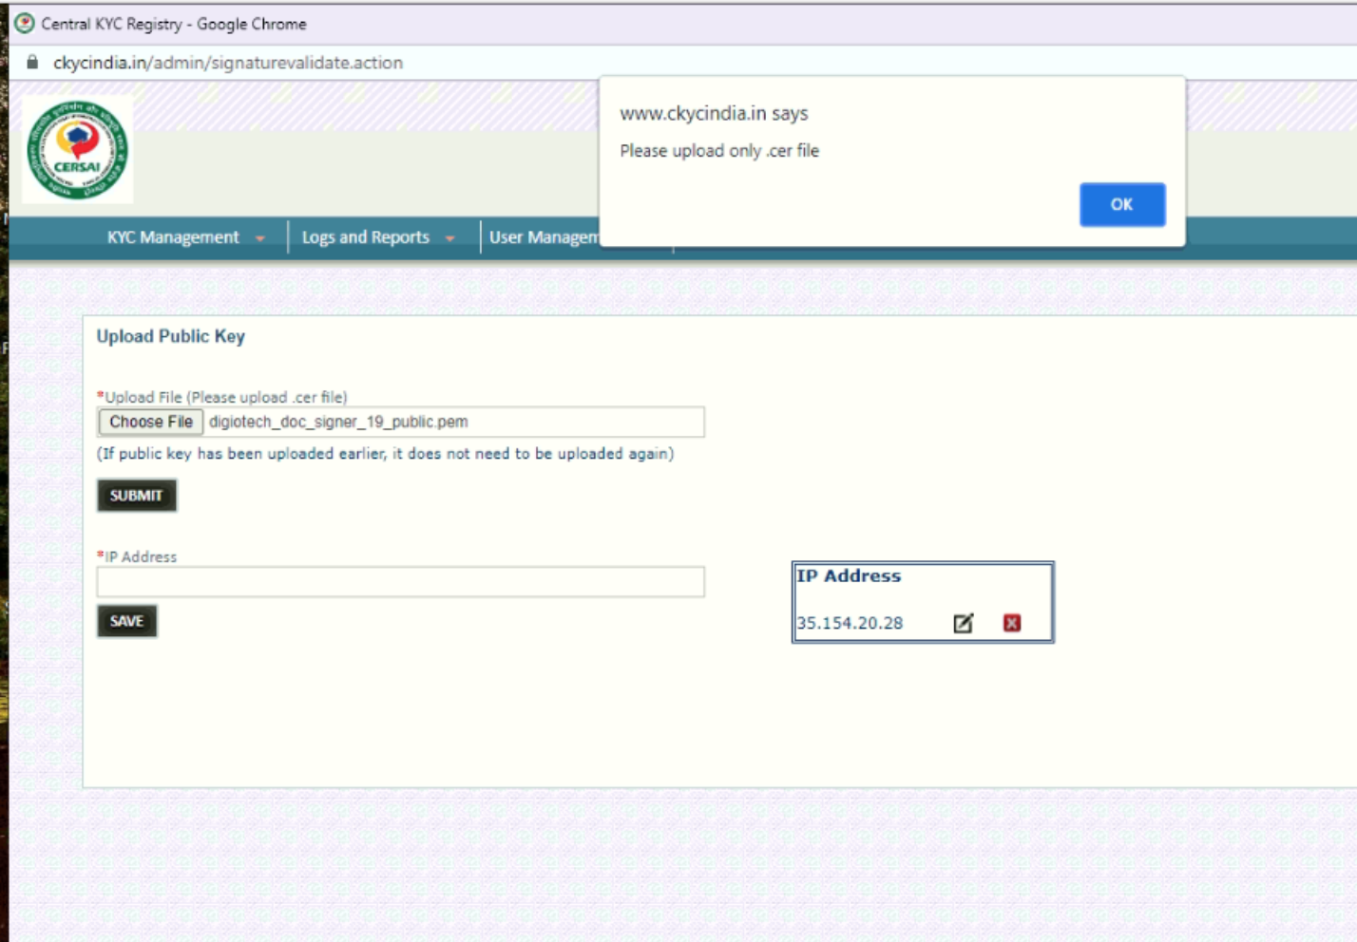

Key Generation:

* Corporate should generate keystore in .jks format. [<https://drive.google.com/file/d/1alaWz_CPZhGnrG6_t_qGHwEN2akQsc7O/view?usp=sharing>]

For Dockerised Deployment one should follow the following:

* [<https://hub.docker.com/r/digiotech/digio-ckyc>]

For Fat-JAR Based Deployment:

* [<https://drive.google.com/drive/folders/1JnjVamE2ak0dAymVSyDSVW4u7hHUxcbC>]

For CKYC Public Key:

* Can be found in API Specification ZIP: [<https://www.ckycindia.in/ckyc/?r=download>]

The Application will be up and running on port: 1423 by default.